ILLUMINATING INSIGHTS FROM UBER EXPEDITIONARY ANALYSIS

INTRODUTION

**1.1 OVERVIEW:**

*Uber is a multinational transportation network company that operates a ride-hailling platform. it was founded in 2009 by Garrett camp and Travis Kalanick and is based in san Francisco, California. Uber provides a convenient way for individuals to request rides from drives who use their own personal vehicles .Uber Driver Analysis refers to the Analyzing the number of trips taken by Uber drivers can provides insights in to their overall activity and the demand for rides in specific areas .Daily, Weekly, or Monthly Analysis: Ubre's data can be analyzed on a daily, weekly, monthly basis to understand the trends and patterns of trip volumes.*

**1.2 PURPOSE**

*This analysis can help identity peak hours or days of high demand and optimize driver availability during those times. Trips can be analyzed based on geographic regions or specific cities to indentify areas with higher demand. Uber captures the required data from two sources –the application (client) itself and the backend services used by the application .client logs are generated automatically by the platform .the rides data science team uses data to improve and automate all aspects of uber’s core ridesharing product .key subteam include Driver ,Forecasting, Global Intelligence ,Maps, Marketplace controls, Matching, Pricing/Loyalty, Rider, and uber for Business.*

**2 PROBLEM DEFINITION & DESIGN THINKING**

**2.1 EMPATHY MAP**

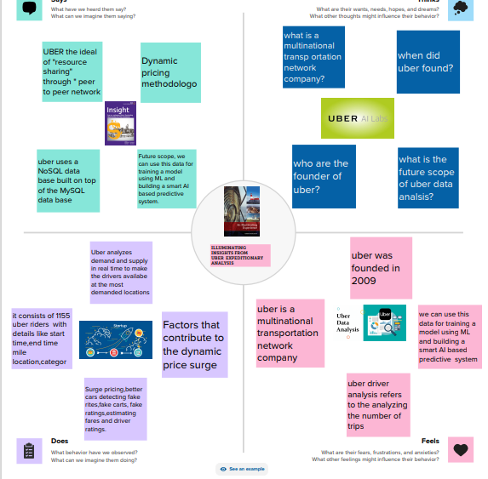

**2.2 IDEATION &BRAINSTORMING MAP:**

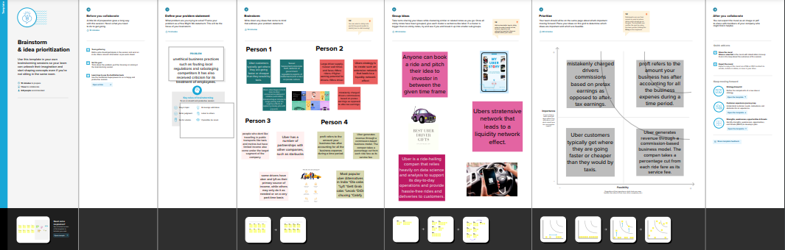

3. RESULT

3.1 DASHBOARD

*A dashboard is a graphical user interface [GUI] the displays information and data in an organized, easy-to-read. Dashboards are often used to provide real-time monitoring and analysis of data, and are typically designed for a specific purpose or use case. Dashboards can be used in a variety of settings, such as business, finance, manufacturing, healthcare, and many other industries. They can be used to track key performance indicators[KPYs], monitor performance metics, and display data in the form of charts ,graphs, and tables.*

Dashboard 1

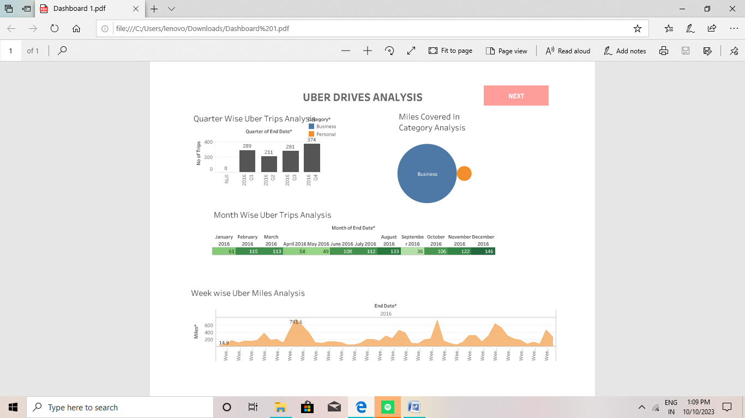

*Dashboard 2*

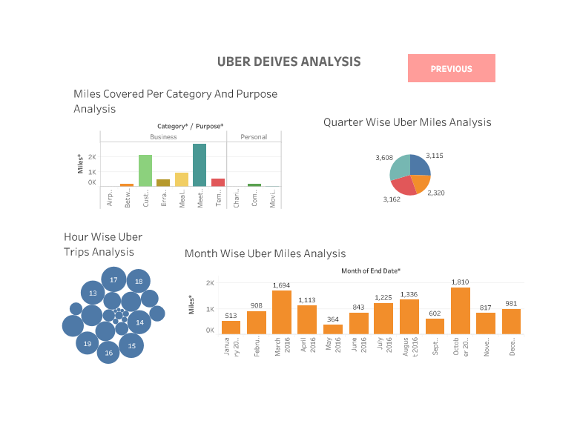

***3.2 STORY***

***A data story is a way of presenting data and analysis in a narrative format, with goal of making the information more engaging and easier to understand .A data story typically includes a clear introduction that sets the stage and explains the context for the data, a body that presents the data and analysis in a logical and systematic way, and a conclusion that summarize the key finding and highlight their implications. Data stories can be told using a variety of medium, interactive visualization, and videos.***

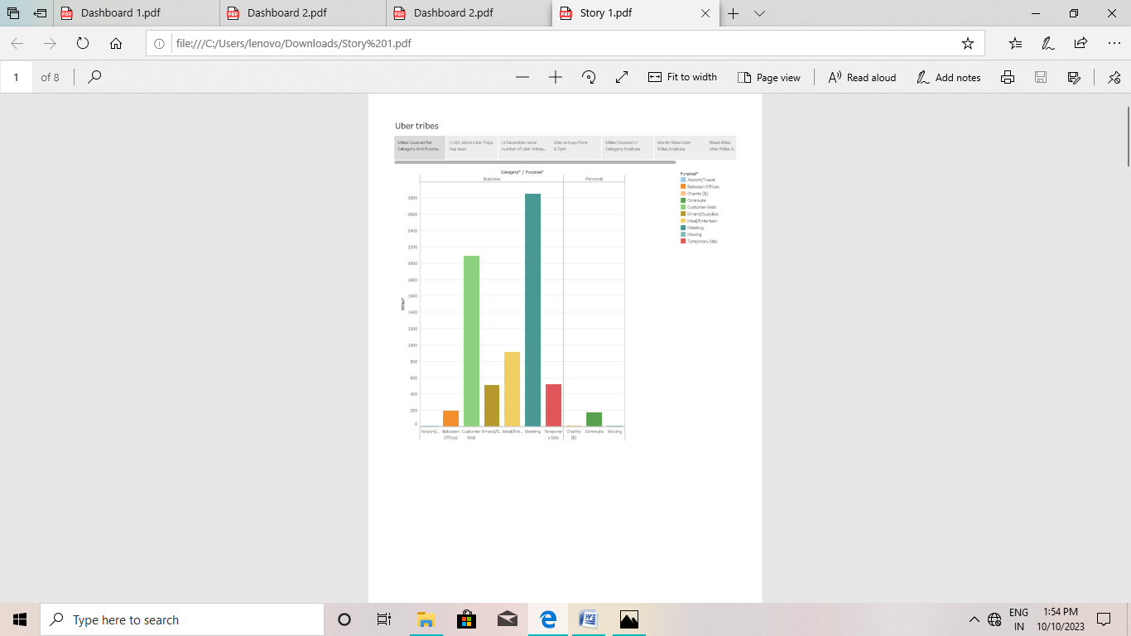

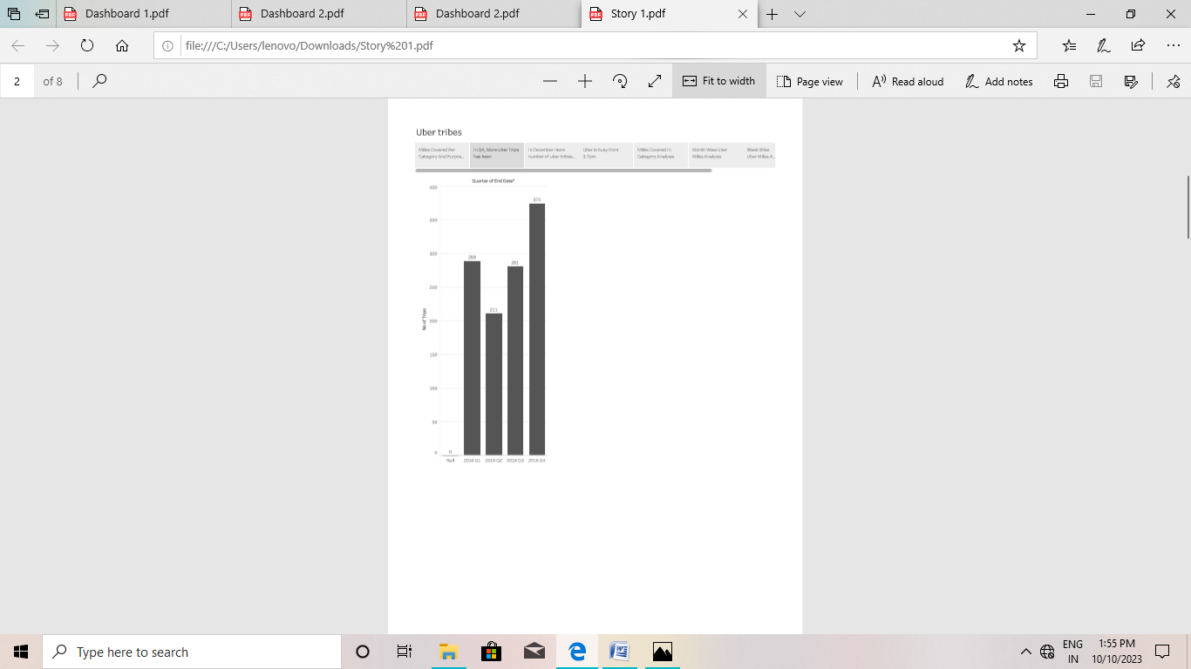

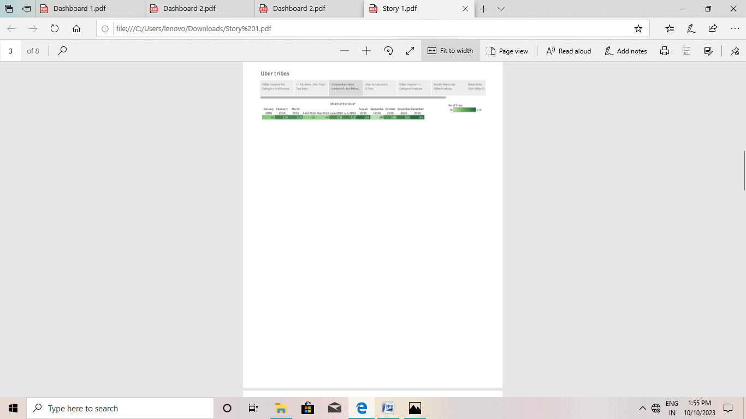

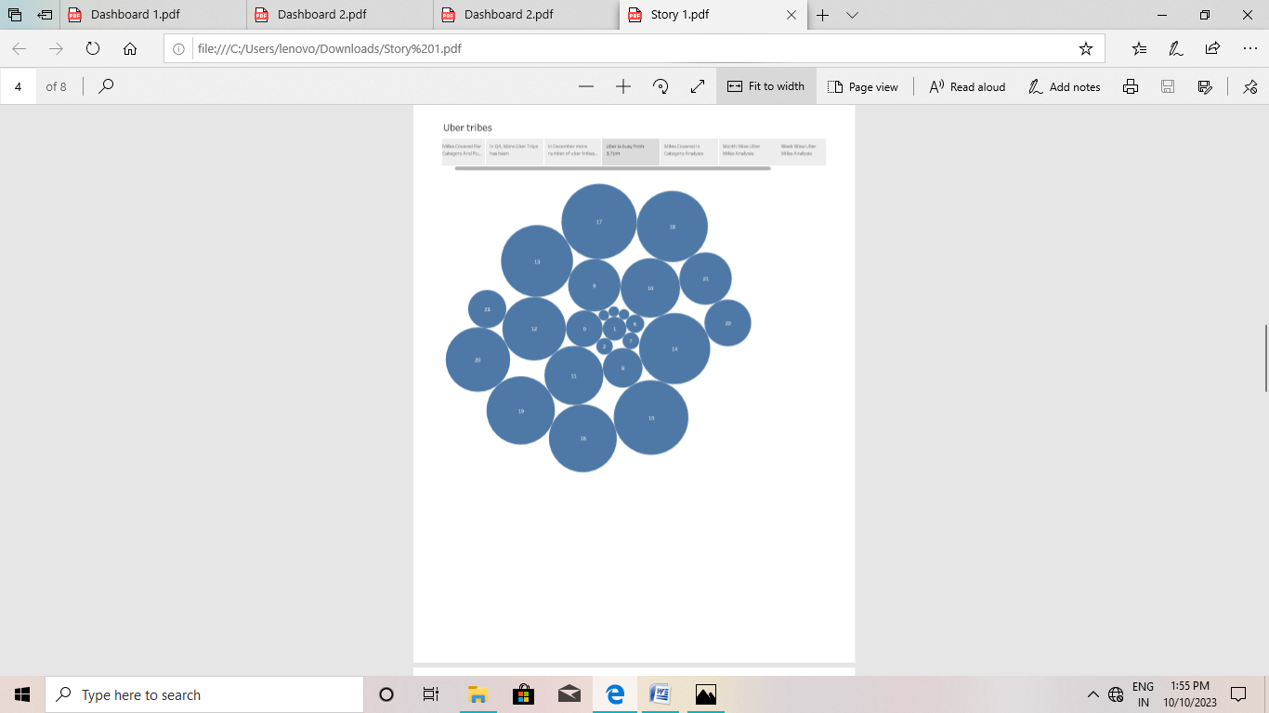

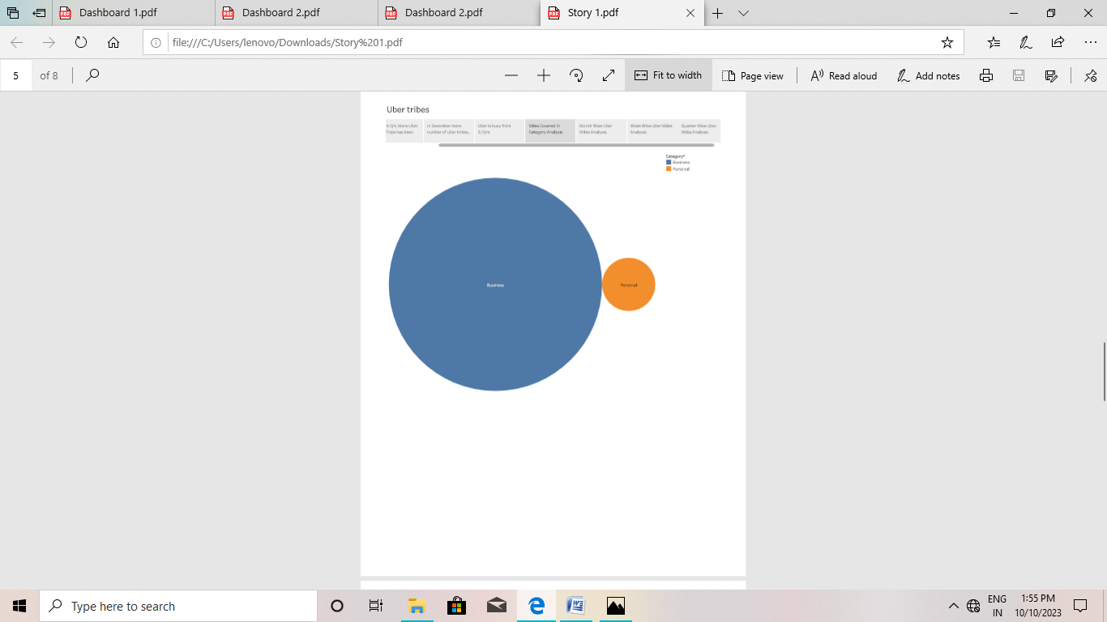

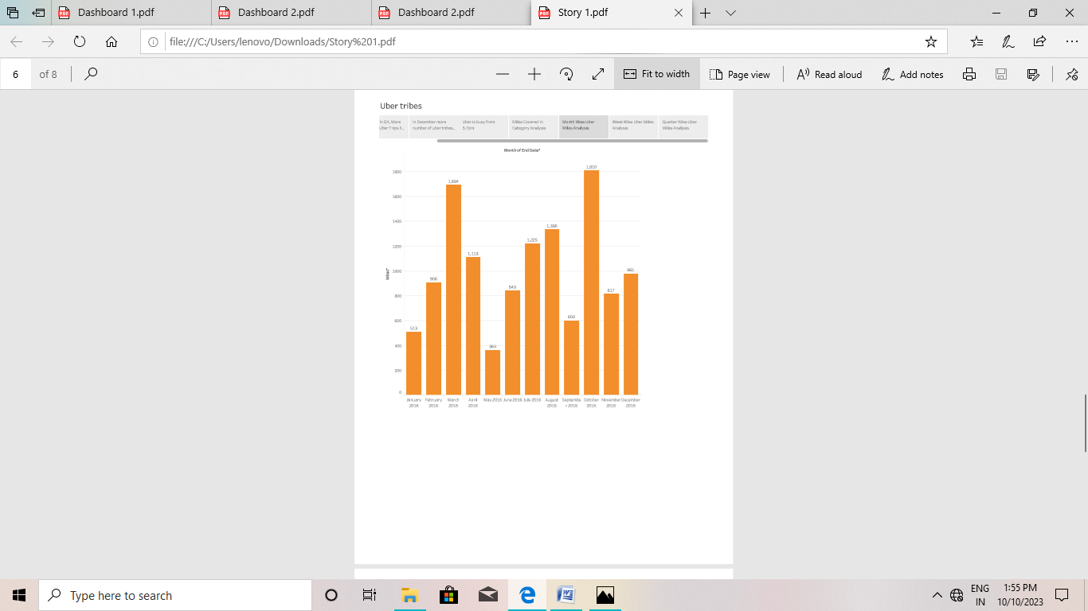

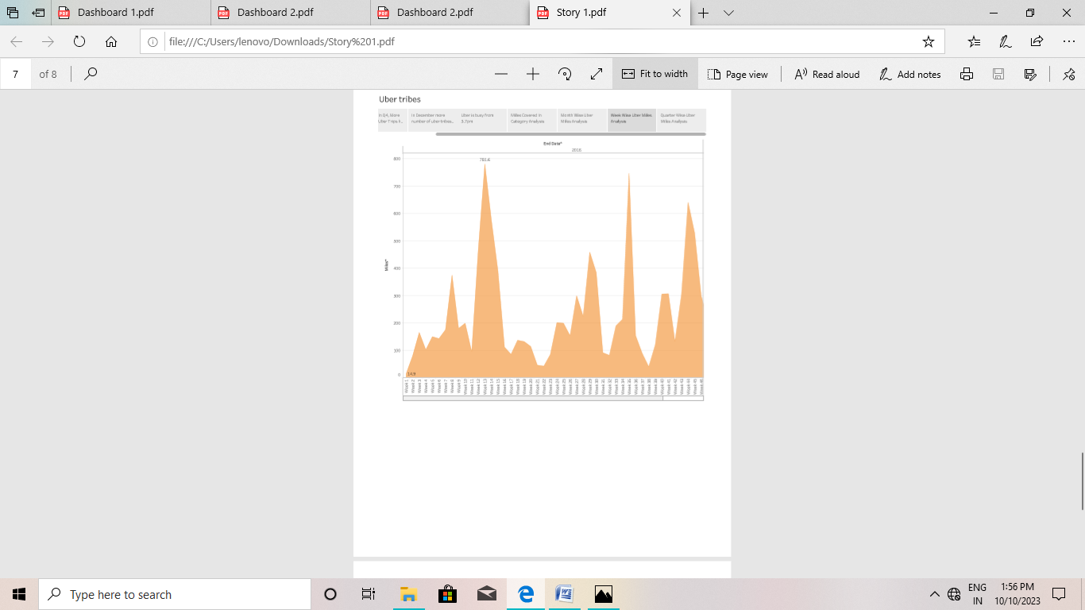

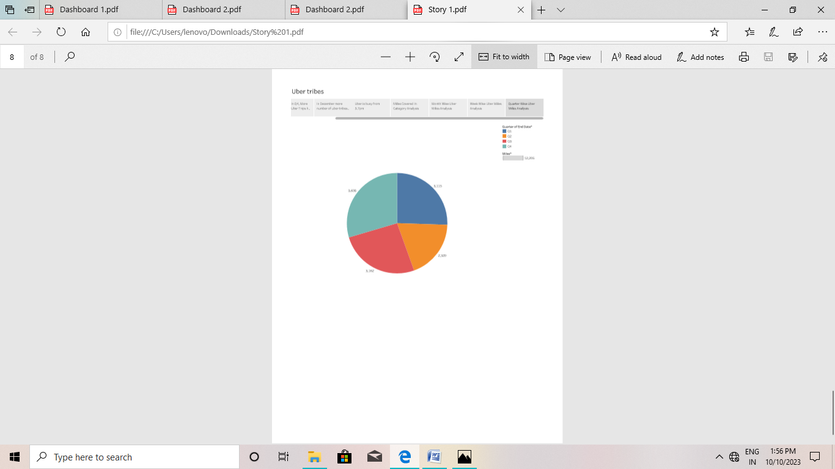

**ADVANTAGES:**

*Uber provides a convenient way for individuals to request rides from drivers who use their own personal vehicles. Uber Driver Analysis refers to the Analyzing the number of trips taken by Uber drivers can provide insights into their overall activity and the demand for riders in specific areas.*

**DISADVANTAGE:**

*Uber’s advantages include door-to-door convenience, safety, and reliable quality, Uber’s disadvantageinclude its surge pricing and the negative effects of replacing steady jobs**with gig work****.***

***APPLICATION***

*This analysis can help identify peak hours or days of high demand and optimize driver availability during those times. Trips can be analyzed based on geographic regions or specific cities to indentify areas with higher demand*

***CONCLUSION***

*Trips can be analyzed based on geographic regions or specific cities to Indetify areas with higher demand . This analysis can help uber driveers decide where to focus their driving efforts for maximum efficiency and profitability.*

*FUTURE SCOPE*

*We can use this data for training a model using ML and building a smart al based predictive system .Model can automatically send the insights to the authorities or drivers related to areas having most trips and passenger count in certain areas. This big data can be used to study passenger’s behavior.*